

Arduino based water level indicator with Motor Control.
Group # 04
Sec- A
MOHAMMOD, RAFID | (19-39917-1) (42 )
AHMMED, EHSANUL | (18-37857-2) (26 )
MAHABUB MITHILA SHARMIN | (17-34928-2) (05)
BIJOY KRISHMA SUTRADHAR | (15-30233-2)(10)
MST SADIA KHAN (18-36906-1)(18)
SHUVO, SHIHAB HOSSAIN (18-34928-1)(14)
IBRAHIM KHAN SHOVO (18-36161-1)(12)
NIBER MAHMUD (17-35732-3)(09)
HASAN SHARIAR CHOWDHURY (15-30943-3)(44)

Name of the Course Teacher
Nadia Nowshin
Assistant Professor

Summer Semester 2019-2020,
September, 2020

Arduino based water level indicator with Motor Control.

Abstract— A common problem which leads to the wastage of water is water tank overflow. To deal with such problem many solutions are present like ball valves which automatically stops the water flow once the tank gets full. But being an electronics enthusiast, it would be only logical to find an electronic solution for it. So here is a simple and handy DIY solution that give us the process of making a circuit which will through detection of water level will raise an alarm when the level reaches to a preset level or once the water tank is full[1]. Water level indicator is a modern way of measuring the water level using latest technologies like sensors, Arduino. The goal of this report is to calculate the water level at any instant of time and trigger the buzzer if the tank is empty Entirely and the motor will start automatically. The motor will be stopped if the tank is full. This can be achieved by using Arduino and ultrasonic sensor.
Index Terms— DIY solution, ball valves,
ultrasonic sensor, Arduino UNO.

Introduction
In a world of decreasing water, the we have to find ways to save more and more water. The problems of water have infected the whole world. These problems are increasing excessively. Clean water is a resource that is becoming scarce. All while the water supply is decreasing, the effort to save it is increasing.
This project is a way of contributing to a solution of the decreasing water problem. This project allows a user to actively decrease waste of water. We thought, what is better to do for a regular consumer. It was either to inform the consumer that the water is filled or to automatically turn off the motors as soon as it got filled. We hence thought that it is better to create a fully automated system that allowed us to only turn the system on and let it control itself.

This paper is structured as follows:
In Section II, we discussed about previous researches of automated water tank systems or water saving methods. The basic working principle of the whole project is explained in section III, while the section IV explains how the project was prepared and a simulation was implemented. The section V contains the results and discussion of the project. The section VI contains the future works and the possible improvements that can be done. The section VII simply concludes our project.

Literature Review
In a research by Md.Sourove Akther ,Momin, Md.Sahid Hasan, Samiul Islam it was found that in this time of digital technology maximum important works related to daily life and industrial are being handle by machine and most of them are depend on automation and control system.Water is one of the most necessary thing use in daily life and on industrial uses also the major uses of water in our country is on agricultural sector so it is very much important in our country to save water wastage. In case of water uses in home and industrial sector basically water used to store in a tank via a motor and the owner or observer have to turn on and off the switch of the motor.If in case the switch doesn’t turned off on time than the tnak will overflow after reaching its maximum capacity and sometimes if the motor switch is on and if the tnak is empty means no getting the supply of water for any possible reason than there is a high chance to damage the coil of the motor. In the research they construct a system to reduce these things named Digital Water Level Indicator and Automatic Pump Controlling System which will control these factors.[2]In another research by Soumya Das , Susmita Dhar , Pratyusha Biswas Deb and P.S.Majumdar was focused on micro controller based water level indicator and controller Their system mainly works on a principle that water conducts electricity. 4 wires are dipped into the tank with a certain gap between each will indicate the different water levels. Based on the outputs of these wires, microcontroller displays water level on LCD as well as controls the flow of water by controlling the motor.[3]In another research by Mohan Mali , Sandeep Shinde, Satish Kale. It was focused to develop a system that will work as a Live Water Level Indicator with SMS and Voice Call Alerts using Arduino and Ultrasonic Sensor. Which will sense the water level and by conditions it will send sms and call to the owners number.[4]
BASIC IDEA OF PROJECT
In figure 1, The first idea is when the Tank is Empty The Motor will automatically start. At that time the buzzer will beep and Red LED will turn on.
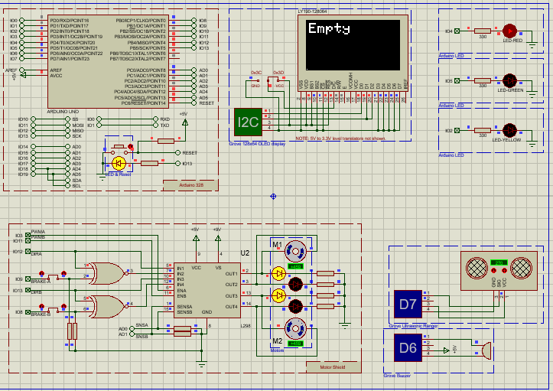
Fig: 1 Empty
Another idea is to stop the motor when it is full

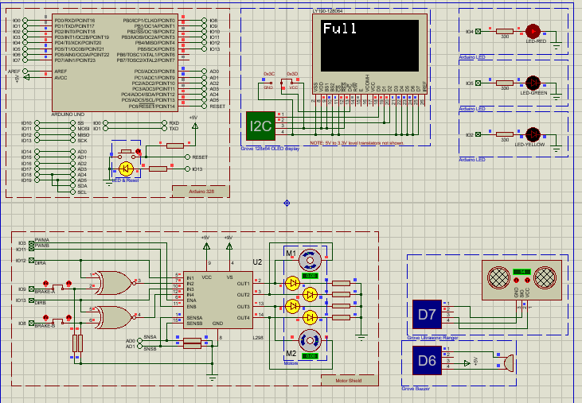Fig 2: Full

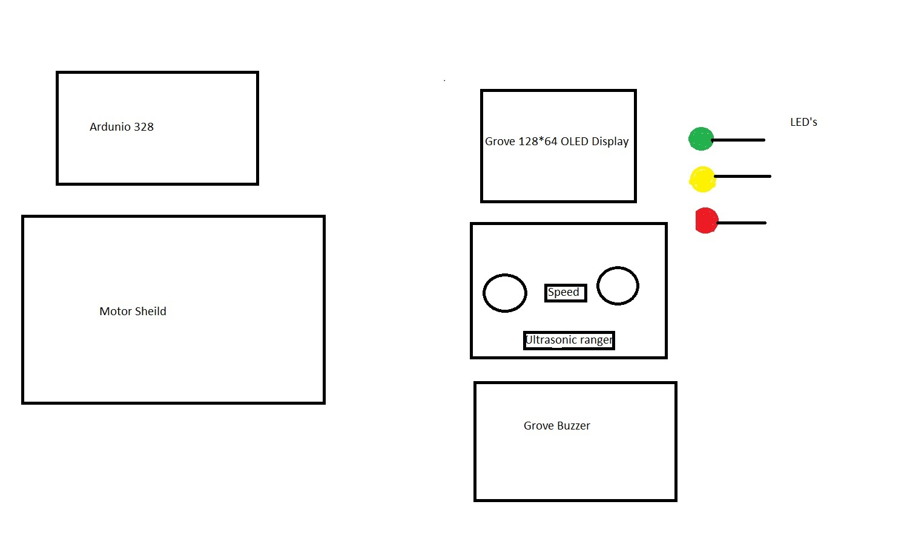
Figure 8: Block diagram
This is Block diagram is the basic implementation of The project

SOFTWARE IMPLEMENTATION FOR ARDUINO BASED WATER LEVEL INDICATOR WITH MOTOR
First of all, the proteus 8 professional was opened with the run as administrator option. Then a Flowchart Project from the proteus window was selected to start the process. After that, two windows appeared and they were Schematic Capture and the other is Visual Designer. In the Schematic Capture window, there will automatically appear Arduino Uno. After that from the Schematic Capture window, ‘Arduino Motor Shield with DC Motors’ will be imported through ‘import project clip’ option from Arduino Library. In the same way Arduino Red, Green and Yellow LED Breakout board and was imported. From Grove Library the ‘Grove Buzzer’ and ‘Grove Ultrasonic Sensor’ was imported. Finally, from the Visual Designer window and ‘Add peripheral’ option Grove 128X64 OLED display was taken. The distance is measured by the ‘Ultrasonic Ranger Module’ from the upper side of the Tank to the surface of water using echo. The value is calculated in centimeter unit and in flowchart the value is returned by ‘readCentimeters’ Function. If the Tank is Empty, both the motors will start automatically. After The Motor is start it will continue until the Tank is Full. When The motor will start. At that time, the buzzer will sound for 1 sec and red LED will be turned on. If the Tank is half, one of the motors named M2 will be stop. When the Tank is ‘Near Full’ or ‘Near Empty’ The Yellow LED will Turn on. When it is near full the Green LED will turn on..
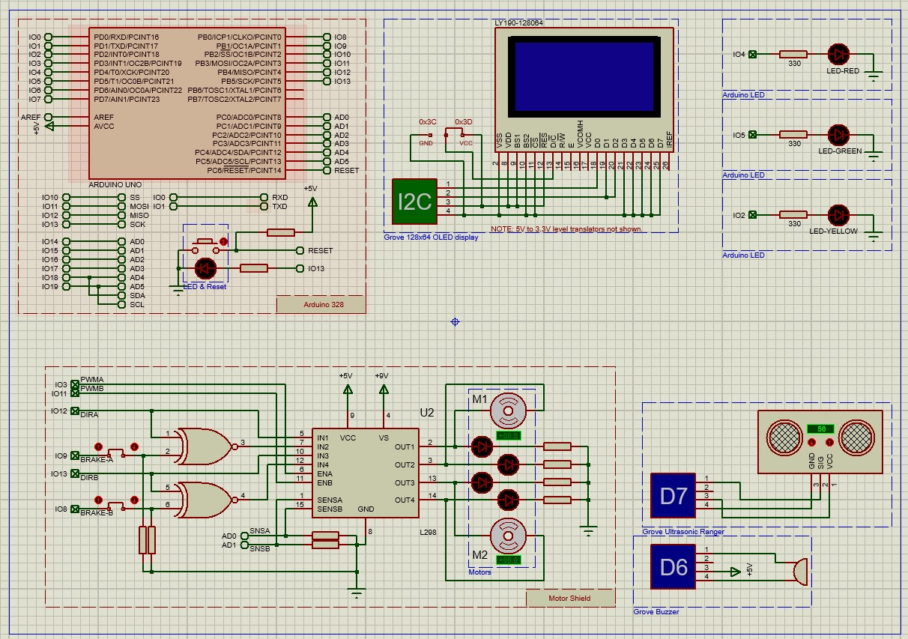
Figure 9: Schematic Capture view.
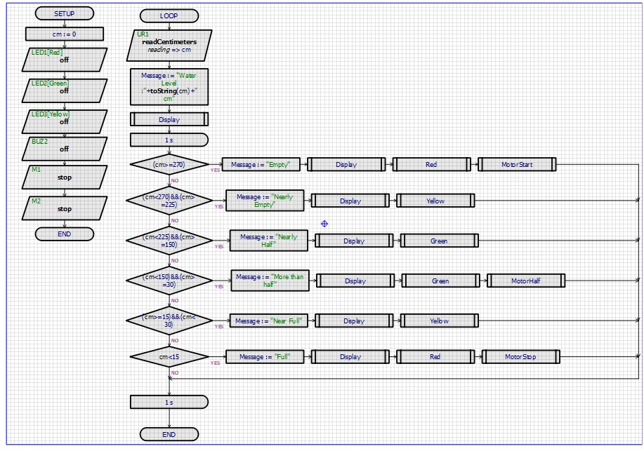
Figure 10: Flowchart_01
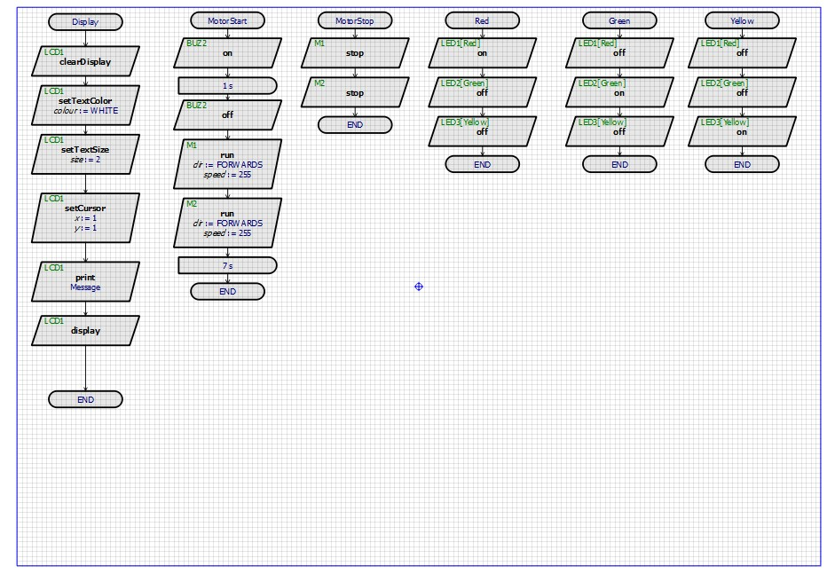
Figure 11: Flowchart_02
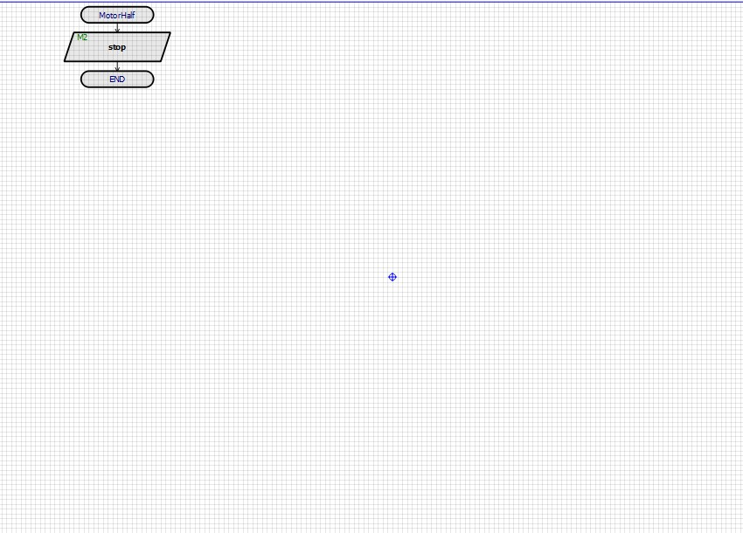
Figure 12: Flowchart_03
In the Schematic Capture view of Figure_09, The circuit was implemented using the instruments. In the Flowchart 1 and 2 The logic was implemented.

FUTURE WORK / Society and Environmental Impact

This project is a small stepping stone to a world of automated water tanks. This project can be expanded to a point where a fully automated system can be built. A system where the changing conditions would send notification to the user. It can also be determined so that a user can fully control the tank and water pumps with their mobile phones. Child proofing, motor speed control, vacation mode, and many more features can be added that can increase the functionality, controllability, and the efficiency of the whole water supply system.

RESULT AND DISCUSSION
In figure 1, it has been seen that when cm was greater than or equal 270 then create a message “Empty” these were shown in display and on Red LED light and starting the motor. In motor starting condition set delay in 7s if we don’t delay in 7s otherwise the buzzer was stay on. We wanted to delay in stay 1s on after that it was off.
Fig: 1 Empty
In figure 2, it has been seen that when cm was less than 270 or greater than or equal 225 then create a message “Nearly Empty” these were shown in display and on yellow LED light and running the motor.
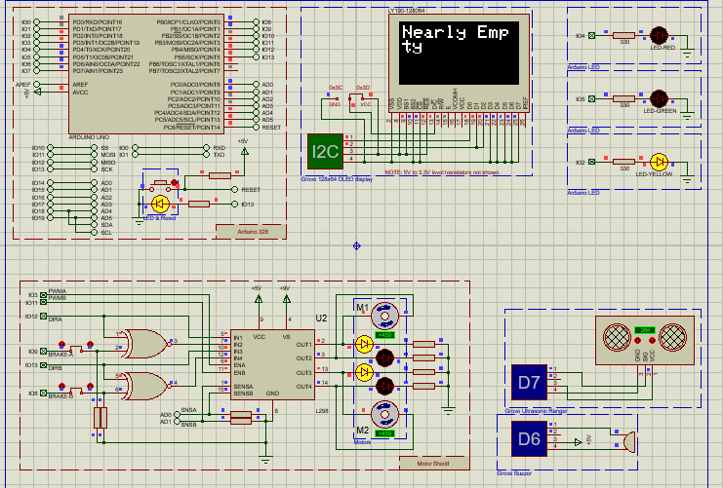Fig 2: Nearly empty
In figure 3, it has been seen that when cm was less than 225 or greater than or equal 150 then create a message “Nearly half” these were shown in display and on Green LED light and also still running the motor.
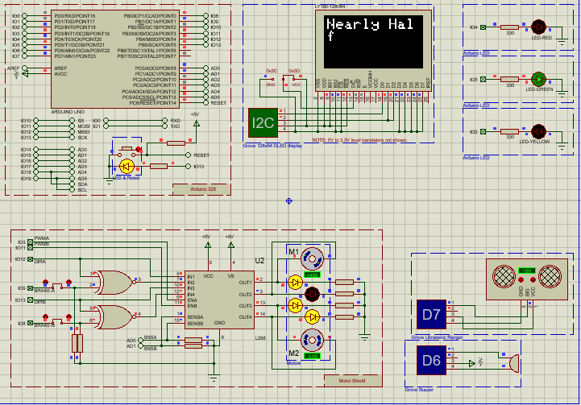Fig 3: Nearly half

In figure 4, it has been seen that when cm was less than 150 or greater than or equal 30 then create a message “More than half” these were shown in display and again on Green LED light and the second motor was stopped.

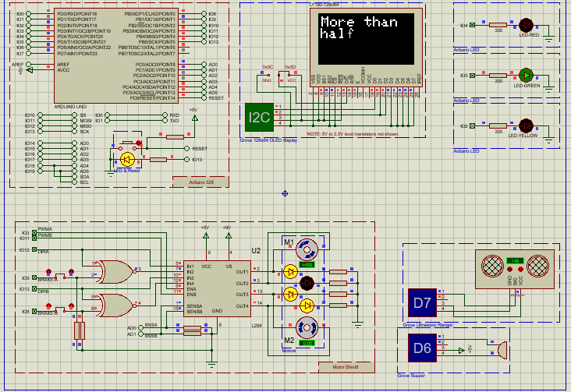
Fig4: More than half
In figure 5, it has been seen that when cm was greater than or equal 15 or less than 30 then create a message “Near full” these were shown in display and again on Yellow LED light and the second motor was still off condition
Fig4: More than half

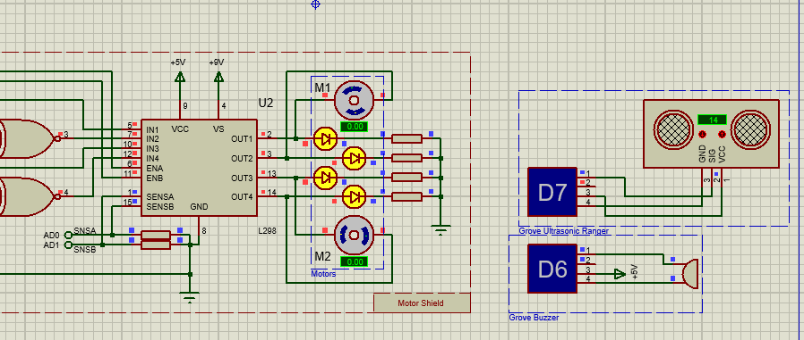
Fig 5: Stop 2 motor

In figure 6, it has been seen that when cm was greater than or equal 15 or less than 30 then create a message “Near full” these were shown in display and again on Yellow LED light and the second motor was still off condition.
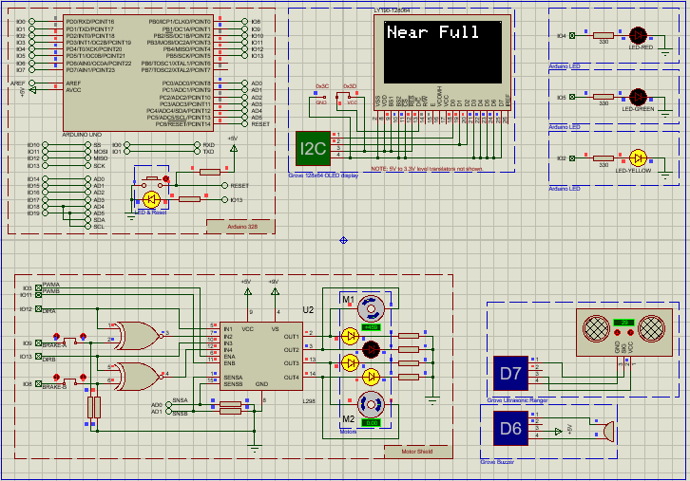Fig 6: Near full

In figure 7, it has been seen that when cm was less than 15 then create a message “Full” these were shown in display and again on Red LED light and the first motor was stopped.
Fig 7: Full

In this system, sea water has supplied into the water reservoir during tide. There, the Fresnel lens are used to concentrate the sun light. Concentrated sun light uses to vaporize the sea water and vaporized water separates salt and gathers in two edge of Fresnel lens and rolling down to the fresh water reservoir.

CONCLUSION/limitations

This prototyped model is made for preventing the wastage of the water. We believe our simulation has a very big place in the real world. This project has a lot of potential to save a lot of water around the world. Especially in Bangladesh, where it is visually determined whether tank is a filled or not.

References
- TARUN, D. A. D. I. T. I. R. U. M. A. L. A. (2020). A Project-Based Lab Report WATER LEVEL INDICATOR USING AURDINO AND ULTRASONIC SENSOR. TCRLS.Das, S., Dhar, S., Deb, P. B., & Mujamdar, P. S. (2017). Microcontroller Based Water Level Indicator and Controller. Asian Journal of Applied Science and Technology (AJAST), 1(5), 181-182.
- Mali, M., Shinde, S., & Kale, S. (2019). Live Water Level Indicator with SMS and Voice Call Alerts using Arduino and Ultrasonic Sensor. IJCSET (www. ijcset. net), 9, 2231-0711.
- . Momin, M. S. A., Roy, P., Kader, M. M. G., Hasan, M. S., & Islam, S. (2016). Construction of Digital Water Level Indicator and Automatic Pump Controlling System. International Journal of Research, 1-5.R. K. Kodali, “Smart waste water treatment,” IEEE Region 10 Symposium (TENSYMP), 2017, pp. 1-5.

